**Patent Draft**

**Submitted by:**

Group 63 CS

Saurabh Mishra

Shakti Maddeshiya

Shivanshu Singh

**Title:** AI-Powered Plant Disease Diagnosis System

**Field of Inventions:**

This project serves in the field of Precision Agriculture. Precision agriculture, also referred to as precision farming or smart farming is an approach, to managing practices that utilizes artificial intelligence (AI) and other cutting-edge technologies to optimize different aspects of farming operations. The main goal of precision agriculture is to enhance crop productivity minimize resource wastage and improve sustainability in the field of agriculture. Below is an explanation of precision agriculture based on AI.

* Deep Learning and AI Integration: At the heart of precision agriculture is the utilization of advanced AI techniques, particularly deep learning, to analyze vast datasets. These datasets encompass a wide range of information, including soil quality, weather patterns, crop health, and historical farming data.
* Sustainability: Precision agriculture practices, driven by AI, aim to reduce the environmental footprint of farming. By minimizing resource use and maximizing efficiency, precision agriculture contributes to more sustainable and eco-friendly farming practices.
* Pest and Disease Management: AI-powered image recognition and data analysis help identify the presence of pests and diseases. Early detection allows farmers to take targeted actions, reducing the need for broad-spectrum pesticides.
* Decision Support: AI-based decision support systems provide farmers with actionable recommendations. For example, they can suggest the optimal cure for diseased plants.

**Background:**

Agriculture is an integral part of the Indian economy. The Indian agriculture sector employs nearly half of the country's workforce. India is the largest producer of pulses, rice, wheat, spices, and spice products in the world.

* Nowadays there is a massive problem we are facing as the regular increment in the pollution that is affecting us and our environment.
* Our soil and environment are not that suitable and healthy for our crops and as that is the only income resource for smallholder farmers, plant diseases are very common factors that can affect the crops and their income.
* The problem statement for our project is to develop a plant disease recognition and classification system using deep learning.

**Objectives**

* To build a plant disease prediction system using Deep Learning.
* To detect unhealthy regions of plant leaves.
* Classification of plant leaf diseases using features texture.
* To analyze the plant diseases/infections.
* To make this service available on a mobile application that can run on low configuration devices.

**Flow chart/ Model:**

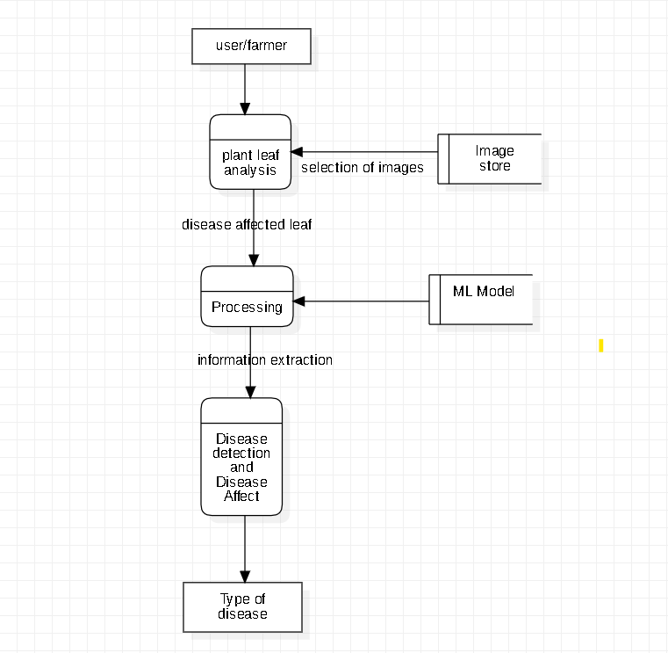

**DFD level 1 for Plant Disease Detection**

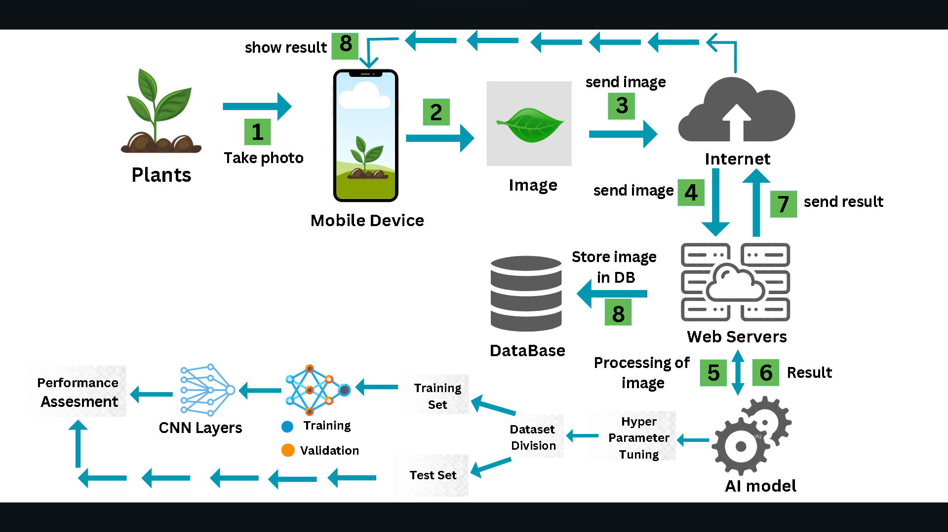

**Workflow representation of the introduced approach**

**Claims:**

AI based mobile application for plant disease recognition, comprising:

* A mobile application works on any low/high end device that uses mobile camera to capture image of the plant leaf.
* That uses a deep-learning based model to predict the possible plant disease with high accuracy.
* A user-friendly UI that is easy to use and can be used in without internet once installed.

**Technology used:**

* + The project starts with installing and importing **Tensorflow, Keras, Matplotlib, NumPy** and other libraries.
  + Then we downloaded the dataset of various images of infected leaves from **Kaggle website** with the help of which we can train our model.
  + The data is then visualized using **imshow** which is used to show different types of leaves which are present in our dataset.
  + Then we apply a Train-Test split to split our dataset according to the test ratio.
  + Then we’ll use **Segmentation process for** image processing.
  + Then we’ll apply Data augmentation to increase the number of labeled images. The classic data augmentation methods include vertical flipping, horizontal flipping, 90° counterclockwise rotation, 180° rotation, 90° clockwise rotation, random brightness decrease, random brightness increase.
  + Then we’ll Build and Train a **CNN** model using various layers and kernels.
  + Then we’ll Export model to a file on disk.

**Abstract:**

* Our project “*Plant Disease Recognition and Classification Using Deep Learning*” is a Deep Learning Model which will detect different Plant diseases by providing just images of the plant and predict the possible disease to the users.
* Initially, the client can either click the image using a mobile camera or upload the image of the affected plant leaf into the model.
* Once the plant disease is tested with the existing trained deep learning model, then this recommends the possible plant disease.
* Our model would be a preliminary tool that could assess the users to select what are some remedial measures to be taken.

**End Users:**

The end user of a plant disease prediction deep learning project could be anyone involved in the agricultural industry, including farmers, crop growers, agronomists, and plant researchers. The aim of the project is to provide these end users with a tool that can accurately and quickly identify plant diseases, allowing them to take necessary measures to prevent or control the spread of the disease and improve crop yield.

**Advantages:**

* Early Warning and Prevention: By identifying diseases at their earliest stages, the system provides farmers with early warnings, enabling them to take preventive measures promptly. This includes targeted treatments, isolation of affected areas, or adjustments in irrigation and fertilization practices.
* Minimized Resource Use: The system promotes resource efficiency by reducing the indiscriminate use of pesticides and other inputs. Farmers can apply treatments precisely where needed, minimizing both costs and the environmental impact.
* Accessibility and Knowledge Transfer: Importantly, the system is designed to be user-friendly and accessible to individuals with varying levels of expertise in plant diseases. It bridges the knowledge gap by providing guidance and recommendations to users who may have limited experience with disease identification.
* Data-Driven Insights: Through the extraction of disease-related features from images, the system contributes to a growing database of agricultural data. This data can be analyzed to gain insights into disease prevalence, distribution, and trends, informing broader agricultural research and policy decisions.

**Conclusion:**

In agricultural field, our farmers frequently face problems as plants are affected by various plant diseases and it affects the overall yield.

So, we are working to develop a deep learning model that can help farmers to predict plant disease in its initial stages which further help them to prevent the disease outbreak and minimize the loss of the crop.

This will help farmers to detect diseases on the crops so that they can timely take the proper cure for their plants.